
COMSATS University Islamabad
Department of Computer Science

ALC354 | Machine Learning Fundamentals
Lab Final Report

SUBMITTED TO: Mr. Anayat Ullah
SUBMITTED BY: M. Awais Riaz (FA23-BCS-060)
Hamayl Ali (SP24-BCS-034)
Class: BCS-5A
Date of Submission: 24th May, 2026
PROJECT REPORT
Zameen.com Price Prediction Model

This is our project about predicting the prices of houses located in different cities of Pakistan. The dataset is collected from one of the top property listings website in Pakistan and is scraped using a manually build scraper. Which is then used to train our model to predict prices based on user input.

Output:
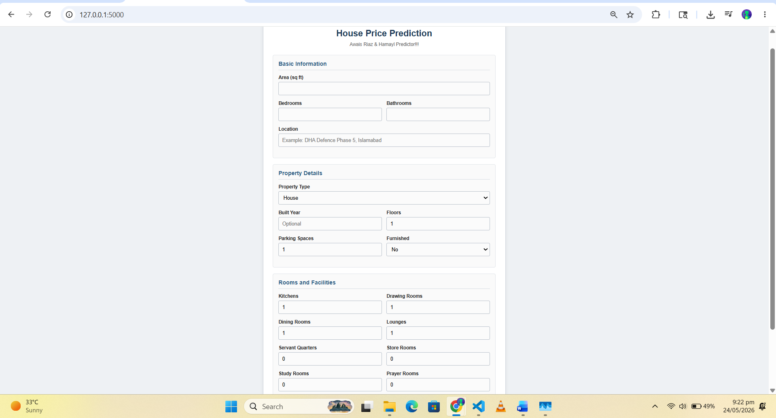

Scraper:
The scraper is built using libraries like requests and beautifulsoup. We have not used libraries like playwright or selenium since it was not needed to use those along with proxies and the website has fewer antibot measures.
First scraper that I initially started with was collecting data from Islamabad region. After completing the project, I decided to extend the scope of the project to other cities as well. So, now, we are provifing a list of top cities and the website is scraped on loop for each city.
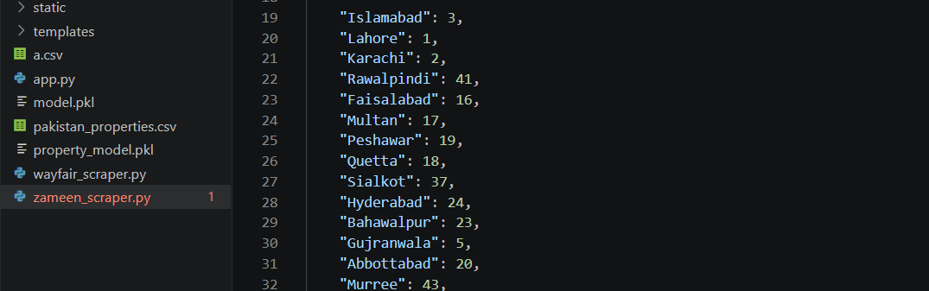

Scraping in progress…
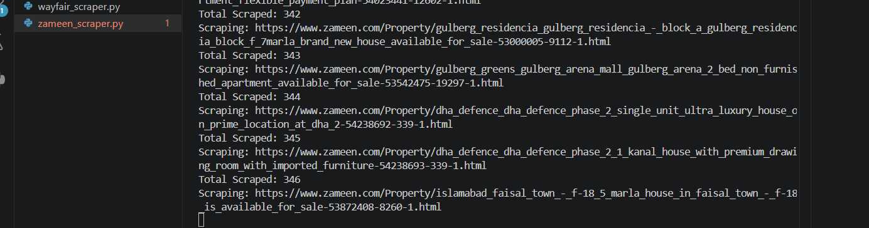

Mistake: I made a mistake in pricing conversion and it was adding extra zeroes. However I fixed it in google colab notebook during model building.

Model Building:
The model was processed and built on a python notebook on google colab [Link]. This notebook takes the csv file from the scraper and transforms it into a pandas dataframe. Afterwards, it’s preprocessed and removed the duplicates, and NaN values (replaced with mode).
We have also studied the dataset in detail to first find out the patterns that could be useful in model building. Some of them are snipetted below.
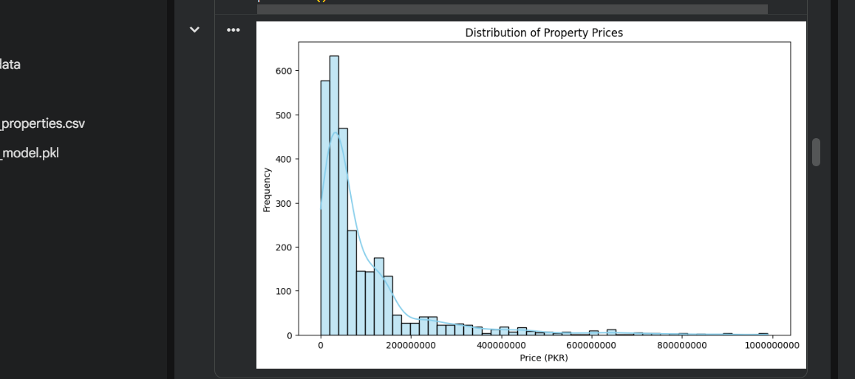
We can see (in real world too) that mostly houses are priced around 2-3 crores at max. And then we are going to see outliers (houses which are really marvellous!)

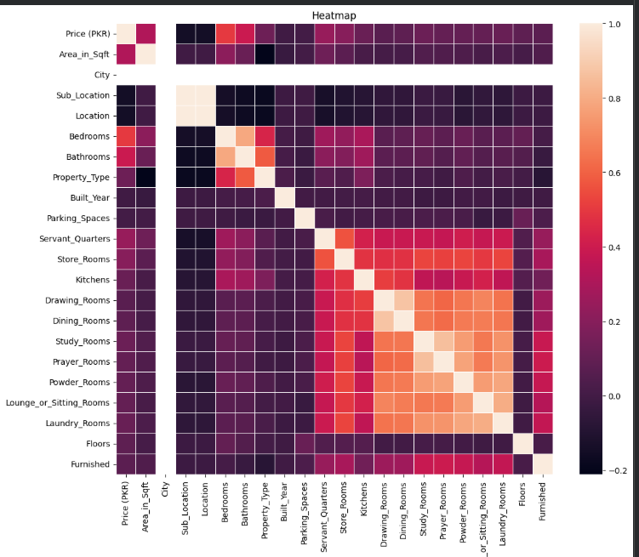
This boxplot here shows the relation between prices and bedrooms which is also kind of linear relation!

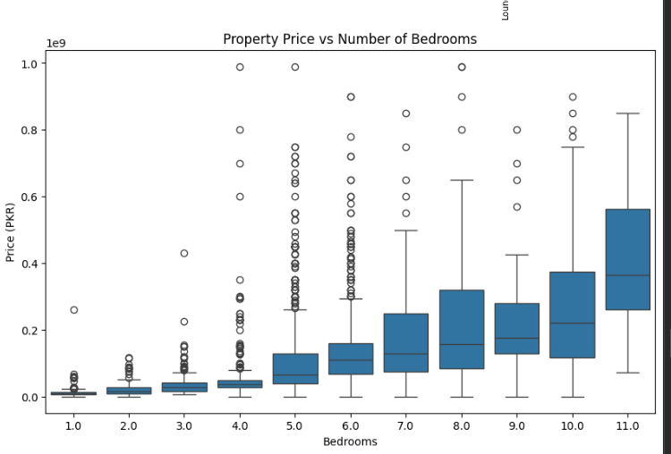

The scatterplot below shows the relationship between the price and Area and coloured by price efficiency. Giving us results which houses are priced better per square foot.

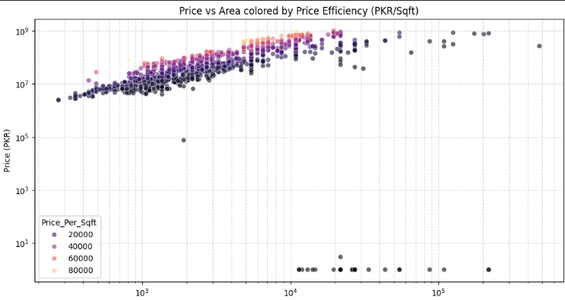

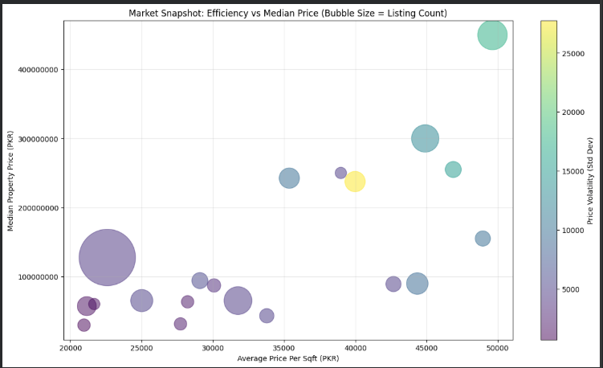
Finally, the market snapshot! (difference between markets in Islamabad sectors and Multan rurals!)
For model building, different ML algorithms were used to find the best performing one. Out of all these, random forest outplayed all of them with an accuracy score of above 80 percent.

Output:
This project comes up with a GUI so that you are not bored looking at black screens. Rather I have added a flask based GUI. That uses the pickled ML model from the notebook and load it dynamically on runtime and makes predictions. It is intentionally kept simple so that not to over complicate the project. It takes several inputs like area, location, number of rooms and bathrooms, sends them to the pickled model to make prediction and then displays the results!

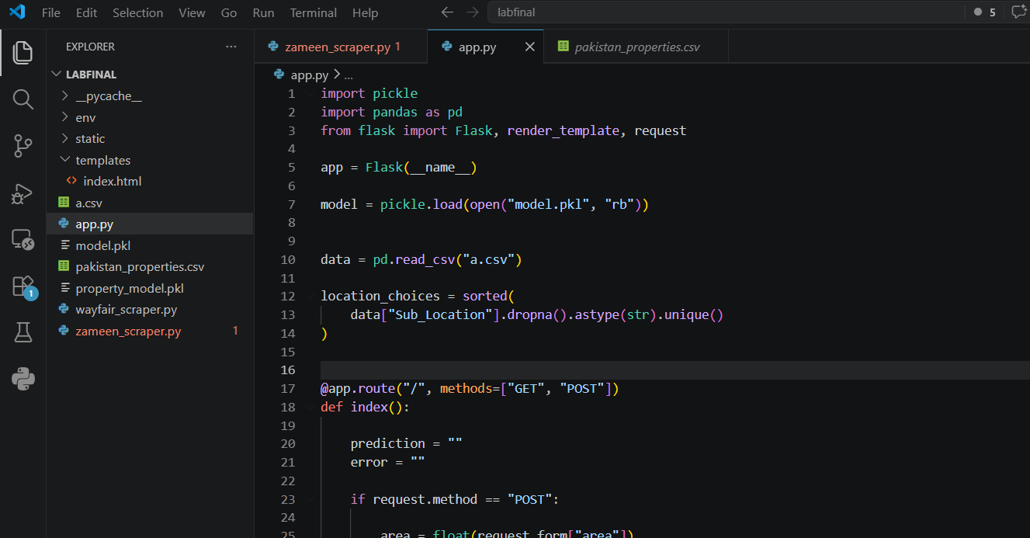
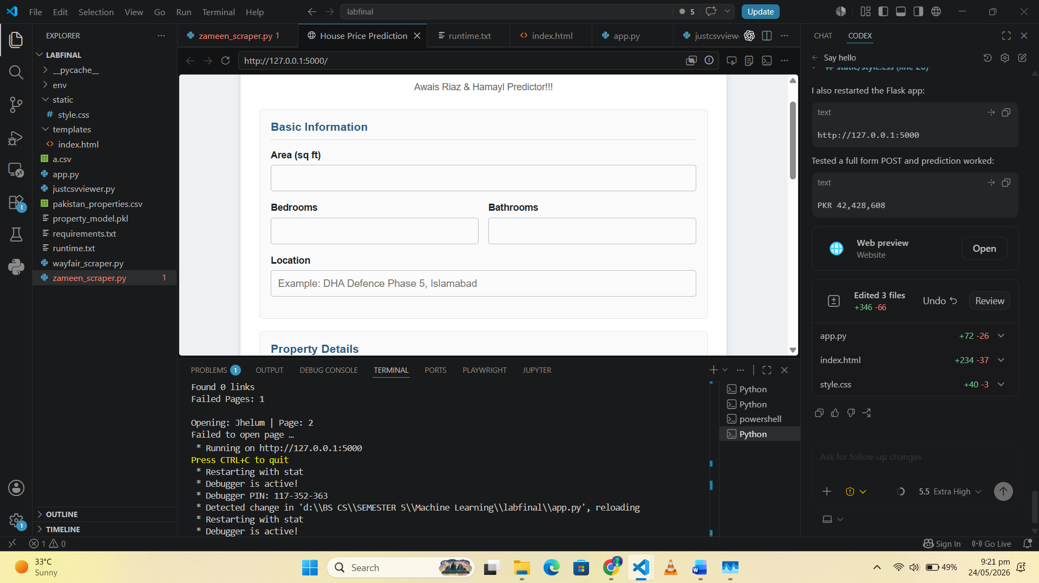

Index.html:
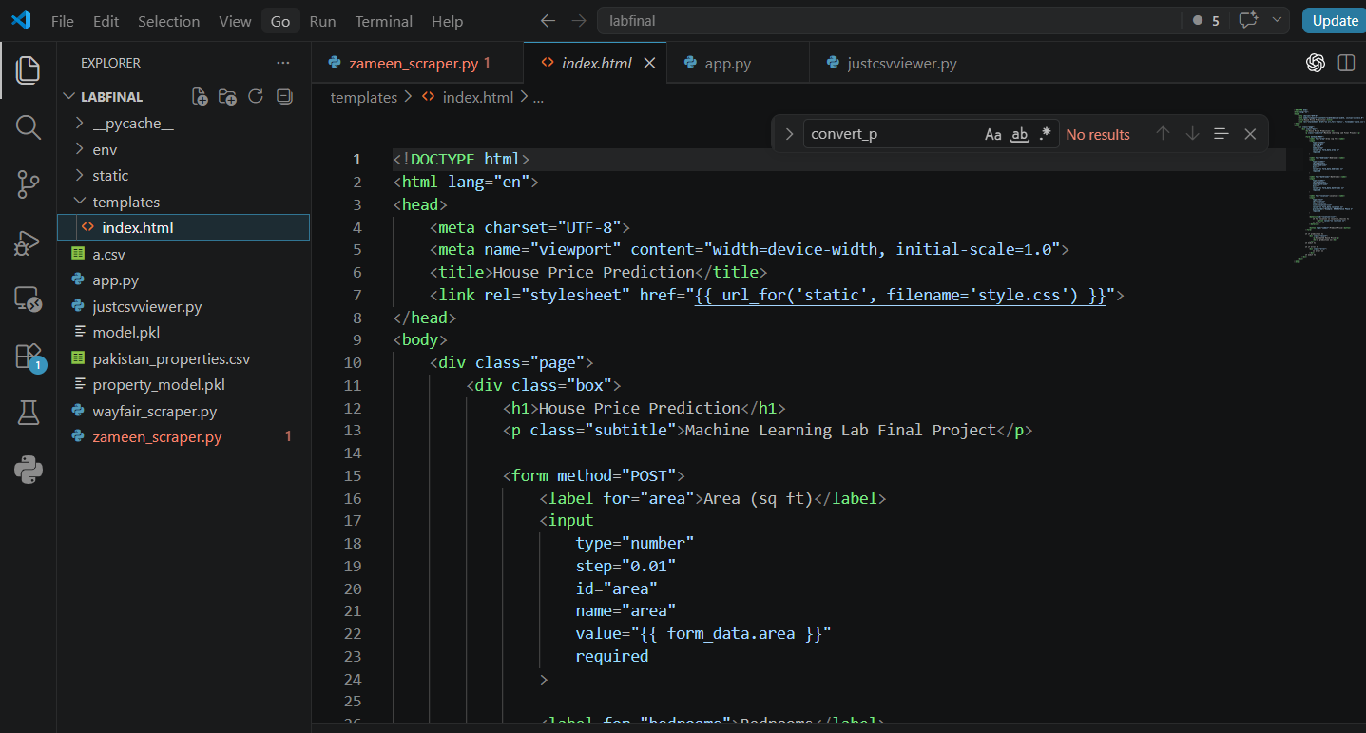

Styles.css:
